2020
«NameLine1» «RegionBrigade» «StationCode»
«OtherName»
«Address1»
«Address2»
«Address3»
«Address4»
«Address5»
«Address6»

Circular: 2021HOC0325AD

16 June 2021

To: All Members

Dear Brother / Sister

NJC Circular 3/21 – National Joint Council Meeting – 3 June 2021

This circular brings members’ attention to the above-named NJC circular which reports:

- The employers’ offer of 1.5% in response to the FBU pay claim.
- The employers’ agreement to the FBU claim for an additional public holiday in respect of the Queen’s Platinum Jubilee in June 2022.

Yours in solidarity.
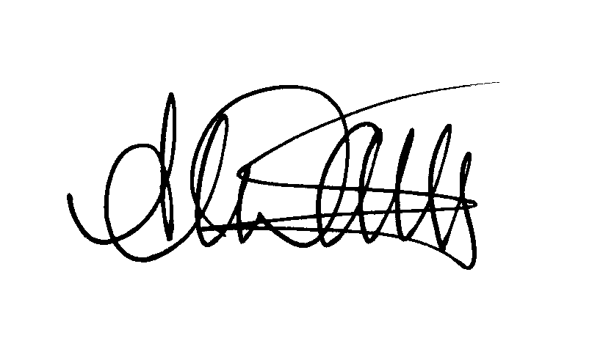
Andy Dark
Assistant General Secretary

Attach.

AD/jh

