Circular: 2017HOC0533AD

TO: ALL MEMBERS

Dear Brother / Sister

MTFA RESPONSE - OFFERS OF CONTRACTS BY FIRE AND RESCUE SERVICES - A REMINDER

Members will recall that a circular was issued in February 2017 which urged members not to enter into agreements with their fire and rescue service to undertake MTFA response. For reference purposes, this was circular 2017HOC0088AD. The advice and content was expanded upon in circular 2017HOC0513AD issued on 20 September 2017.

This circular reminds members of that position and reaffirms that it remains unchanged.

We have been contacted by members who have informed us that their fire and rescue services have embarked on a fresh round of attempts to persuade members to sign a contract to undertake such duties in combination with a somewhat bizarre and desperate attempt to convince members that, in some way, it is already a contractual requirement.

Given that these reports have been received from members in different fire and rescue services we can only assume that this is the result of a central push from within one of the relevant government departments. For the avoidance of doubt, these reports have been received from members who are employed by fire and rescue services in England.

The union remains committed to try to find a resolution to the differences between on the one hand the union and its members, and on the other the national employers on the issue of pay. A key factor in this difference is the matter of funding which needs to be provided by government. We remain hopeful that government will cease urging local employers to cajole firefighters (of all ranks) to undertake this work via an individual (i.e. not collectively agreed) contract, and redirect its efforts and resources into providing the required funding for fire and rescue services.

Quite why government resists this common-sense and reasonable approach, which at the same time would be a demonstration of its commitment to, and respect for, firefighters remains unfathomable.

Members may wish to re-read the previous circulars sent to members in connection with MTFA (and by extension, MTA). These can be accessed via a search on the FBU website.

Best wishes.

Yours fraternally
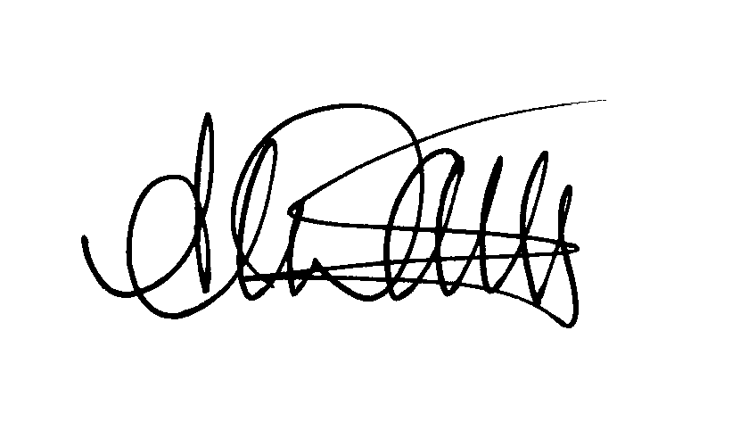
ANDY DARK
Assistant General Secretary

