Circular: 2017HOC0513AD

20 September 2017

TO: ALL MEMBERS

Dear Brother / Sister
MARAUDING TERRORISM AND PAY

Following the membership consultation and the outcome of the Executive Council’s meeting last week, head office has been contacted by members and officials regarding the implications of that decision on marauding terrorist firearms attack (MTFA) and also what is commonly being referred to by fire and rescue services as marauding terrorist attack (MTA).

Members will have read the advice and information we have previously provided on this matter. The most recent circular to members was sent in February (2017HOC0088AD). That circular, as with all previous circulars on the issue, remains extant.

At its meeting on 13 September 2017 the Executive Council did consider the issue and, for reasons of practicality, concluded that the matter should be communicated to members in a circular separate to that addressing the cessation of the trials of EMR and other work. The issue will be discussed again at the Executive Council meeting on Friday 22 September 2017.

As you will know, members in a number of fire and rescue services have previously registered an expression of interest and/or had been prepared to volunteer to be assigned to teams which had been set up to respond to MTFA/ MTA incidents. The Executive Council is aware that a number of such members have indicated to line managers that they wish to withdraw from such activity.
Contd/2…

- 2 -

We further understand that in some instances the local employer has falsely implied or bluntly stated that such work is contractually required.

This is not the case. MTFA and MTA response is not a contractual requirement and as a consequence carrying out training or any other activity connected with MTFA/MTA response is also not a contractual requirement. Essentially, two things govern the activities which firefighters undertake. The first is the contract and collective agreements which create obligations on the firefighter as an employee; the second is any contractual agreement reached between the individual and the employing fire and rescue service.

There is nothing within your contract; nothing within the Grey Book; nor any other collective agreement reached with the FBU which compels members to undertake MTFA/MTA activity.

We also understand that some fire and rescue services have cited the “Home Office view”, “the NFCC* view” and have misrepresented the contents of the Grey Book. To be clear, the Home Office nor any other government department has any locus on employment issues in the fire rescue and service, role maps, or the activities to be undertaken by firefighters. To be equally clear, the NFCC has no role in employment issues in the fire and rescue service, role maps, or the activities to be undertaken by firefighters.

The arguments being deployed by some local employers, government ministers and the NFCC have the same groundless foundation as those deployed in the middle of the last decade in respect of co-responding. Similarly, the assertion by such agencies of the existence of a mythical contractual obligation in respect of co-responding was as incorrect then as are their similar assertions now in respect of MTFA/ MTA.

In short, in the early 2000’s employers took action asserting a contractual obligation by quoting partial elements of role maps and other documents entirely out of context. Those actions, and the employer’s refusal to back down and accept the futility of their position, resulted in a court case where the employer’s arguments were found to be baseless. It appears that history may be repeating itself.

What makes the position even more ludicrous is, that unlike the situation which existed at that time, at this current time in respect of MTFA and indeed EMR, the FBU and its members would be prepared to reach an agreement but for the employers and the governments unwillingness to meet the reasonable measures which we have asked for, on behalf of members, in return.

Contd/3…

- 3 -

We have been informed that there is at least one MTFA exercise which is scheduled to take place before the Executive Council meets on Friday - and affected members have sought advice particularly because the local employer is insisting that the matter is contractual.

It is unfortunate that the fire and rescue services involved, and those advising them, have created this entirely avoidable debacle. In advance of the Executive Council discussion taking place on Friday, the members in the affected brigades are advised that they are under no obligation to engage with this training event/exercise and/or undertake any training or other activity in respect of MTFA/ MTA.

Similarly, in view of the fact that the Executive Council meets on Friday, affected members may choose that on this occasion to engage with this training event/exercise. Given that employers are not prepared to increase members’ pay, provide the required robust and guaranteed compensation payments in the event of injury or death at an MTFA/MTA incident and/or ensure that members’ survivors are provided with an assured adequate pension it isn’t clear why members would undertake training or engage with the exercise. However that is a choice which members will make.

In either case the affected members are strongly advised to ensure that their employer is entirely clear on your position. You are advised to submit a memorandum in accordance with the normal practice in your fire and rescue service. In that memorandum you should make clear that your position and understanding is that engagement in any activity connected with MTFA/MTA response with which you may or may not choose to do is voluntary.

We advise that you keep a copy for your own records. Should you choose to engage with the training/exercise you are advised to verbally inform your line managers in the first instance and to confirm your position in writing as soon as is practicable thereafter.
* NFCC, National Fire Chiefs Council, a structure which has replaced the CFOA committee structure.

Yours Fraternally,
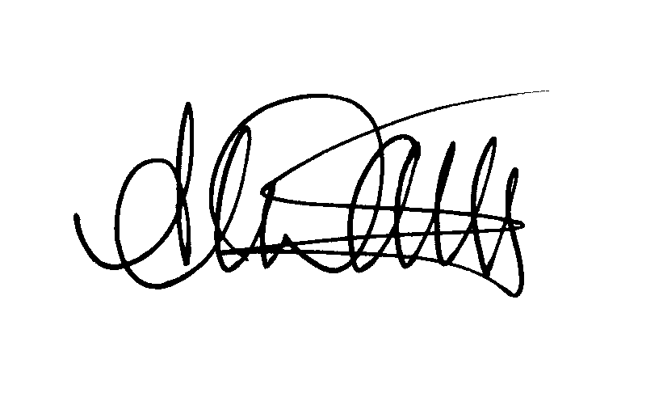
Andy Dark
Assistant General Secretary

