Circular: 2017HOC0088AD

Date: 7 February 2017

Dear Brother/Sister

MTFA RESPONSE – OFFERS OF CONTRACTS BY FIRE AND RESCUE SERVICES

It has come to our attention that some fire and rescue services are asking personnel to sign new contractual arrangements to undertake MTFA response duties. Members will be aware that MTFA has been the subject of extensive work within the NJC workstream and is a key part of the pay terms and conditions settlement discussions.

To date, those discussions have not concluded. There are important issues which need to be addressed, not least those of pay, compensation and pension arrangements for fire service personnel. Members are strongly advised not to sign any new contractual terms either to their existing primary contracts or secondary contracts. Whether by design or bad timing on the government’s part, this initiative is not helpful and undermines the union’s attempts to protect and enhance members’ conditions.

Previous circulars have detailed the elements of the FBU’s position and they are summarised below:

- A satisfactory across the board increase in pay and logically a mechanism for pay rises.
- Payments for skill/activity.
- Each service must conform to strict national protocols to ensure inter-operability and intra-operability between fire and rescue services and other agencies.
- Nationally agreed guidance would be a part of the individual contract, variable by collective agreement with the FBU at national level.
- The usual duty of care requirements and to provide a safe system of work apply to all new activities including adequate training and provision of equipment.
- Under no circumstances will fire and rescue personnel work within the hot zone at an MTFA incident.
- The costs that would be borne by schemes such as the FBU’s AIF scheme (funded by members’ contributions) shall be indemnified by the employers’ or government department.
- Adequate resourcing for the new areas of activity, which will not be at the expense of the existing activity of the UK fire and rescue services.
- Professional standards and operational procedures, with adequate training, competency standards and assessment processes.
- Fire service personnel to be under the control and command only of fire service operational managers at all incidents.
/Cont….
2.

- Mobilisation of fire service personnel and in-call incident handling of fire operations to be undertaken by emergency fire control personnel and not other agencies.
- Adequate arrangements for staffing of fire control rooms.
- Adequate during-call and post-call welfare arrangements for personnel.
- FBU representation rights in all controls where the FBU has members.
- Appropriate inoculations – especially hepatitis B.
- Injured firefighters to have satisfactory pension arrangements.
- In the event of permanent incapacity or death, firefighters and/or their families achieve lifelong household income stability.

No one item can be taken into isolation and the issue of compensation highlights some of our concerns. Currently, fire and rescue services do provide some insurance cover for members injured or killed at an MTFA incident. However, we have witnessed how fire and rescue services with their insurers have fought tooth and nail through the courts, time and again, to not pay out compensation to the injured firefighters and/or survivors of members who have been killed at incidents. The most well-known and pertinent example of this was the Marlie Farm incident where the claimants, the survivors of the two firefighters who were killed plus other injured FBU members, had to wait 10 years whilst the FRS and their insurer resisted the claims in the courts, lodged an appeal when the firefighters and families were successful in the High Court, withdrew the appeal but then went on to prevaricate and delay making actual payment.

The FBU position is that a compensation payment should be immediately payable in the event of injury or death. We have declared our claim at £1 million pounds whilst recognising that one fire and rescue service has an insurance policy where the insured sum is £500,000 in the event of death.

MTFA response is not a contractual requirement of fire and rescue service employees. We have noted, in the past, that members had agreed to do so, but on a voluntary basis. Whilst Conference agreed not to insist that those members should withdraw their voluntary agreement, Conference was also clear that no more members should sign up to do so until a national agreement has been reached.

As above, members are urged not to enter into agreements with their fire and rescue services to undertake MTFA response, whether on a contractual, temporary or voluntary basis until the employers and governments agree to address the issue of pay for any new fire service work, and to address the issue of compensation and enhanced pensions in respect those injured or killed.

Best wishes.

Yours fraternally
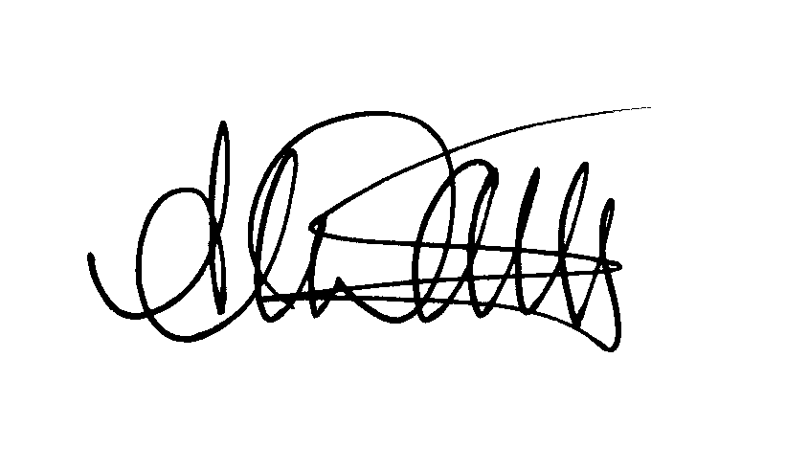
ANDY DARK
Assistant General Secretary

AD/jh

