Circular: 2016HOC0637AD

TO: ALL MEMBERS

2 December 2016

Dear Brother/Sister

DEPARTMENT FOR WORK AND PENSIONS: FIT FOR WORK – ENGLAND, SCOTLAND AND WALES

This All Members circular is primarily for members in England, Wales and Scotland, but is provided to branches in Northern Ireland for information.

Members are advised that the government has recently published new guidance for GPs on 29 November 2016 in relation to the Fit for Work scheme. Essentially, Fit for Work is a programme to assist employers, especially those without occupational health service provision, to hasten employees’ return to work. The new guidance which supplements previous guidance for employees and employers, can be found following this link https://www.gov.uk/government/collections/fit-for-work-guidance

You will note that the guidance is provided in Welsh and English and that arrangements in Scotland differ as shown. Members will be aware of the provisions in Section 5B of the Grey Book which detail the arrangements for occupational health services to be provided.

Occupational health service provision by fire and rescue services is conversant with the health requirements of firefighters and the ill-health provisions in respect of the compensation scheme, and are therefore far more appropriate than the government’s Fit for Work scheme arrangements.

The government scheme is quite clear that “Fit for Work… does not replace existing occupational health services provided by employers”. Employers and GPs can suggest to workers that they are subject to a referral to the government scheme’s occupational specialist. If you are on sick leave, your GP may suggest that you be referred. Such a referral is voluntary on the part of the patient and the doctor and/or the employer must seek and receive the employee’s consent. There is no penalty for not giving that consent.

Members will make their own decision as to whether they wish to avail themselves of the suggested referral. That said, it is difficult for the union to imagine circumstances in which the telephone call-based Fit for Work assessment would match or be superior to the fire and rescue service occupational health service provision.

/Cont….

2.

In the unlikely event that an employer or a GP attempts to coerce you, you should make it clear that you do not give your consent and confirm that to be the case in writing as soon as possible. In circumstances where the employer has tried to coerce you, you should contact a union official.

Further information is available for members in England and Wales using this link:
http://fitforwork.org/general-practitioner/

Further information for members in Scotland is available using this link:
http://www.fitforworkscotland.scot/gps/

Best wishes.

Yours fraternally
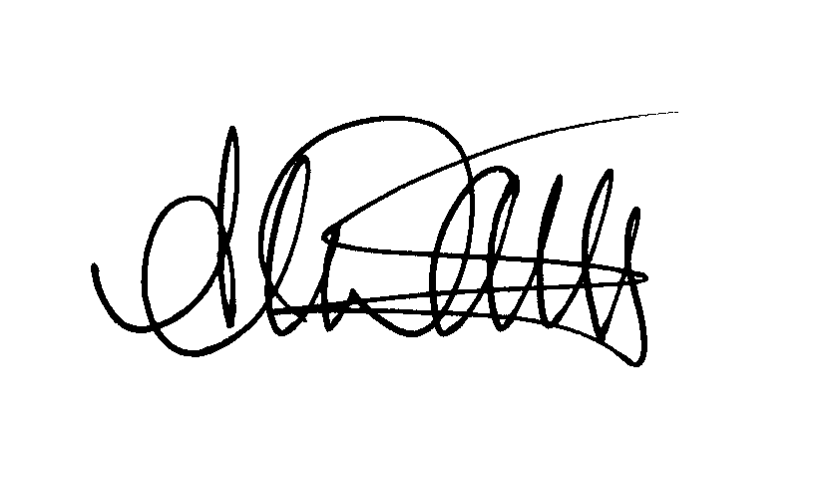
ANDY DARK
Assistant General Secretary

AD/jh

