Circular: 2016HOC0226JM

To: ALL MEMBERS
17th May 2016

Dear Brother/Sister,

SWITCH TO DIRECT DEBIT – APRIL PRIZE DRAW WINNER

I refer to Head Office circular 2016HOC0179JM which brought to the attention of our members the Westminster Governments amendments to the Trade Union Bill and the need to change the way in which members pay their union subscription.

All those members who returned a completed Direct Debit mandate form by 29th April 2016 where entered into a prize draw. The prize for the April draw was an iPad Mini (donated by UIA Mutual Home Insurance) and I am pleased to announce that the winner for this draw was Michael Potter from West Sussex.

If you have not yet completed a Direct Debit mandate form, please do so as soon as possible. You can download the forms from https://www.fbu.org.uk/Switch2DD, or contact your local officials who will be able to supply one.

Please do not forget to complete the check off cancellation form, which will allow us to then do this on your behalf.

Don’t delay – Switch today!

Yours sincerely,
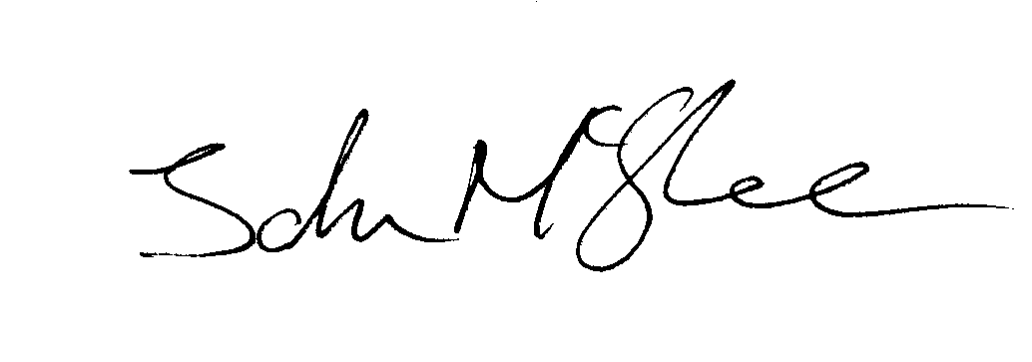
John McGhee
National Officer

JM/jr

